Date -21/10/2023

Roll No. - 13

Expt. No. - 6

K.M.S.P. Mandal’s

Sant Rawool Maharaj Mahavidyalaya, Kudal

**Department of Computer Science**

Signature

Recovering and inspecting deleted files using Autopsy.

Title - _______________________________________________________

_______________________________________________________

Autopsy is an open-source digital forensics platform that is used for analyzing and investigating computer systems and storage media. It is specifically designed to assist digital forensics professionals and law enforcement agencies in extracting, analyzing, and documenting digital evidence from computers and other devices.

**Key features of Autopsy include:**

**1. Disk Imaging:** Autopsy allows users to create forensic images of storage media, preserving the original state of the data for analysis without altering the original.

**2. Keyword Search:** Users can perform keyword searches across the entire dataset to identify relevant information, files, or artifacts.

**3. File Analysis:** Autopsy analyzes files on the disk, providing information about file types, metadata, and relationships between files.

**4. Timeline Analysis:** It creates a timeline of system activity, helping investigators reconstruct events and understand the sequence of actions on the system.

**5. Artifact Analysis:** Autopsy supports the analysis of various artifacts, such as internet history, chat logs, and system logs, to gather evidence.

**6. Hash Analysis:** The platform allows users to calculate and compare hash values of files for integrity verification and to identify known files.

**7.Reporting:** Autopsy provides reporting features to document findings, making it easier to present evidence in legal proceedings.

Autopsy is often used in conjunction with other digital forensics tools and methodologies to conduct thorough investigations into computer-related crimes. It is user-friendly and provides a graphical interface, making it accessible to both experienced digital forensics professionals and those new to the field.

Create New Case

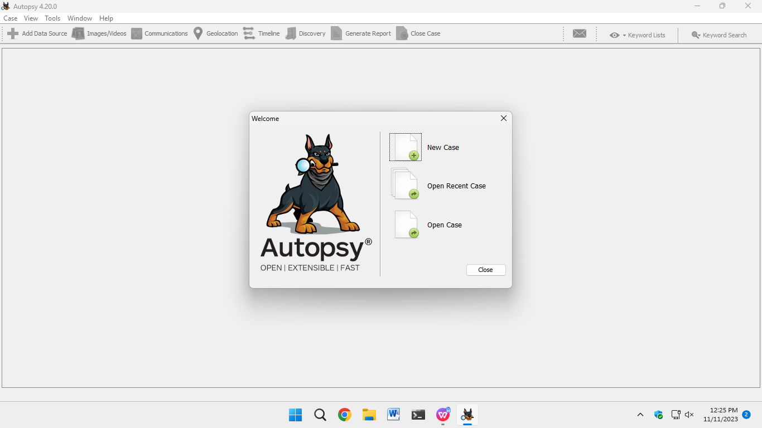

Case Information

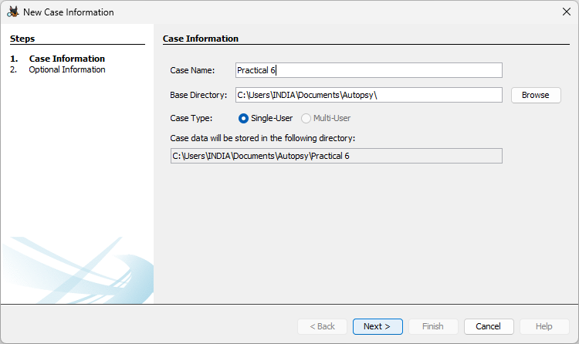

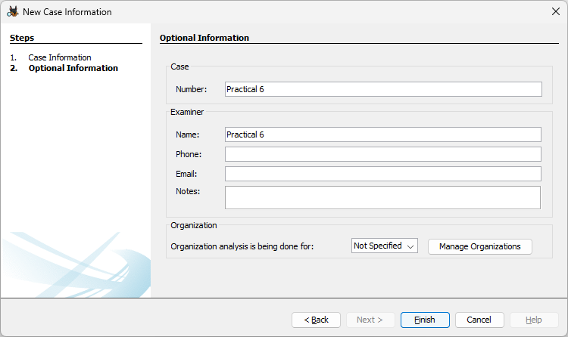

Select Disk for Scan

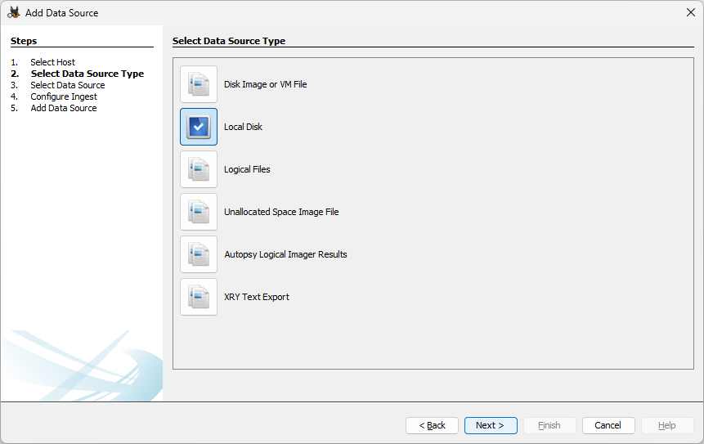

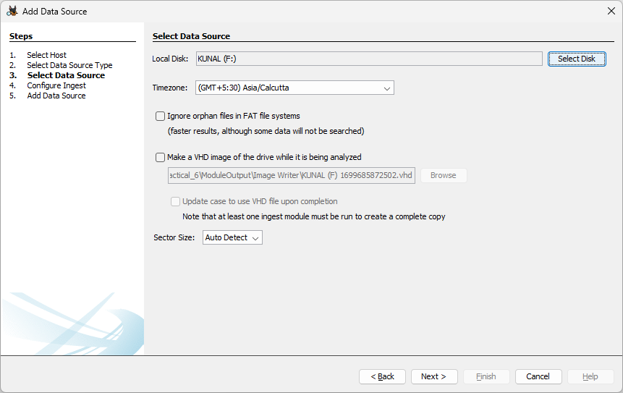

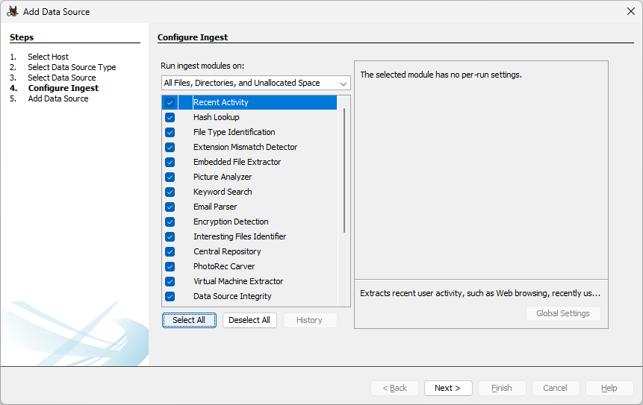

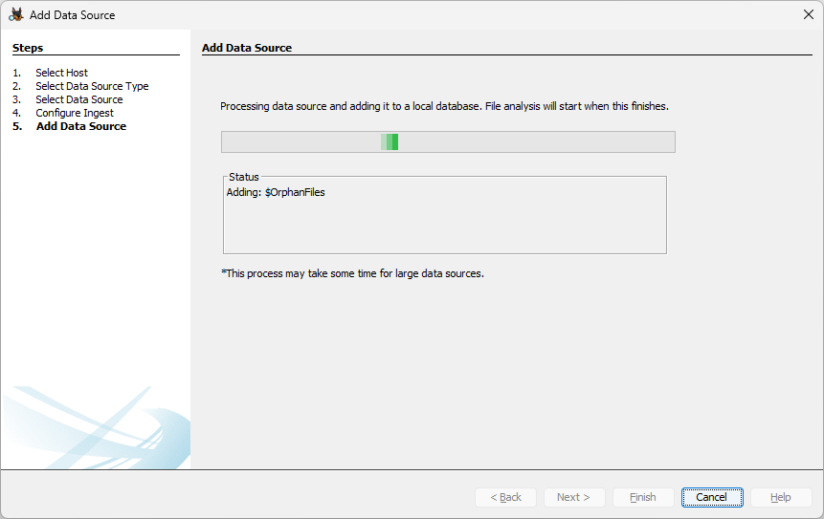

Data Scan Complete

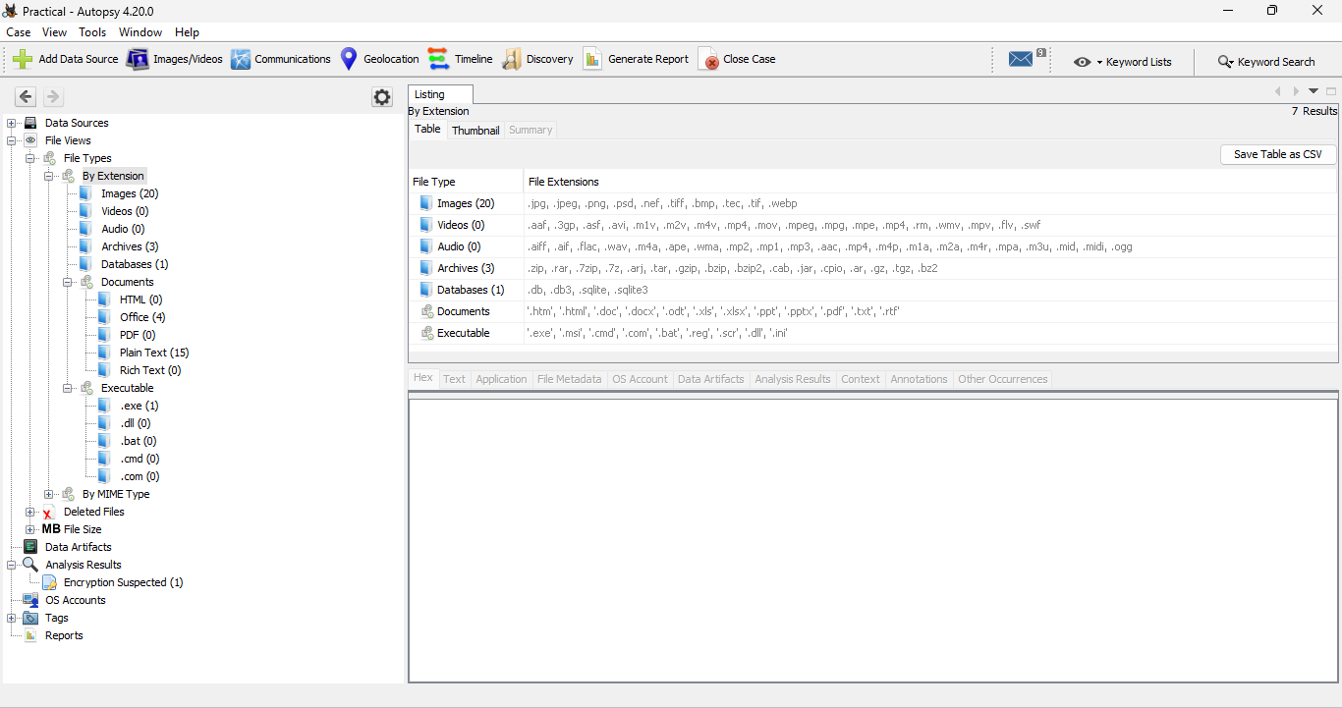

Data Scan Result

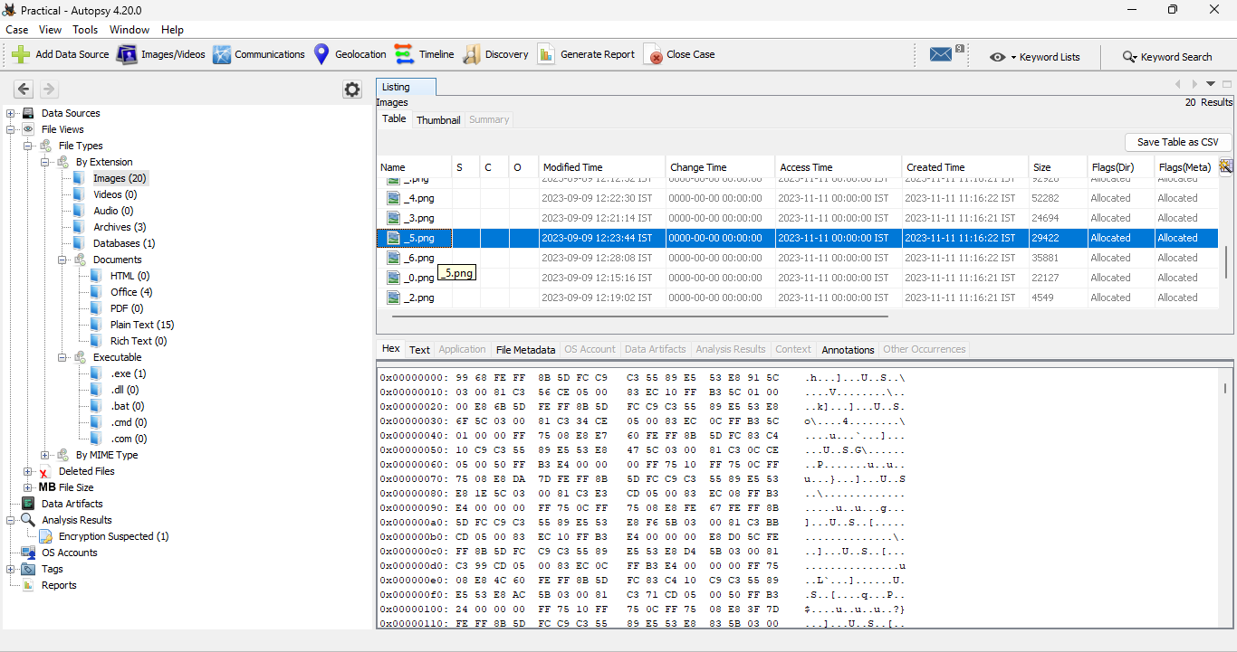

Generating Report in Excel Format

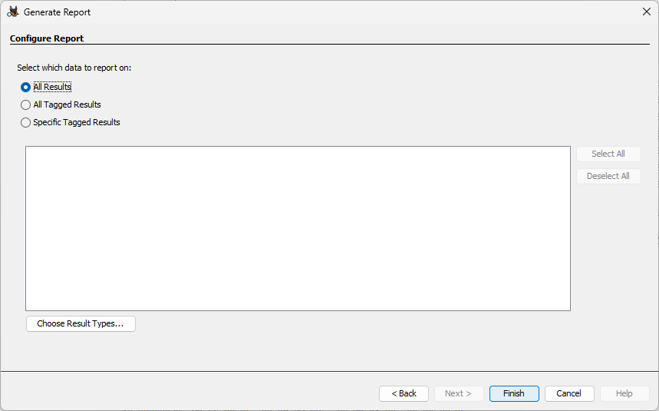

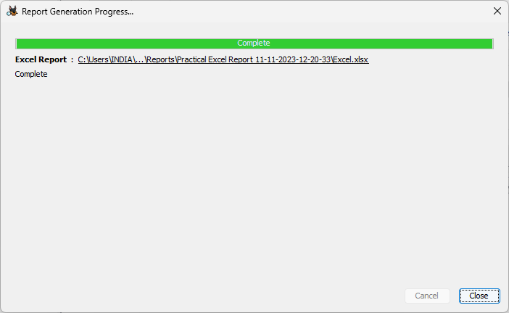

Generated Report

